**OUTPUT SCREENS:**

**HOME PAGE**

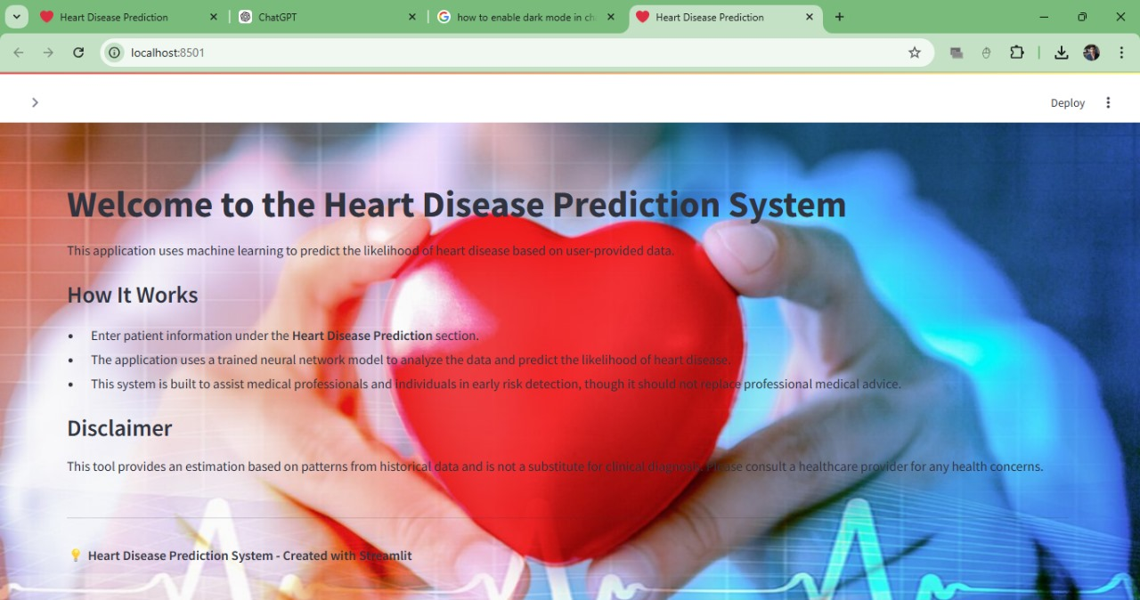

#### MAIN PAGE

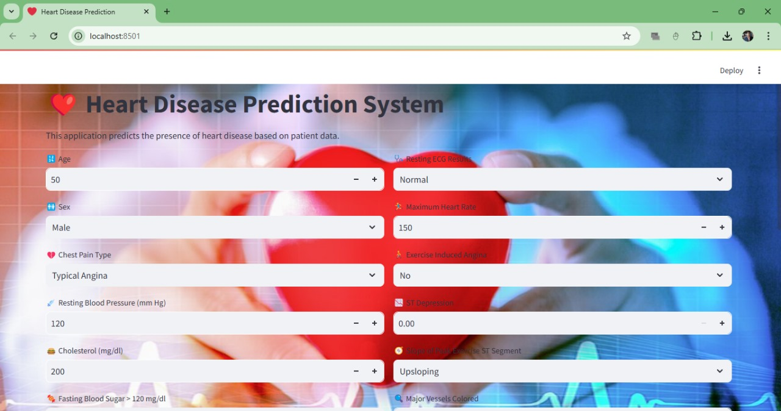

**RESULT PAGE**

